Assignment 2.2
Task 3- Creating a file max-temp.txt in local FS
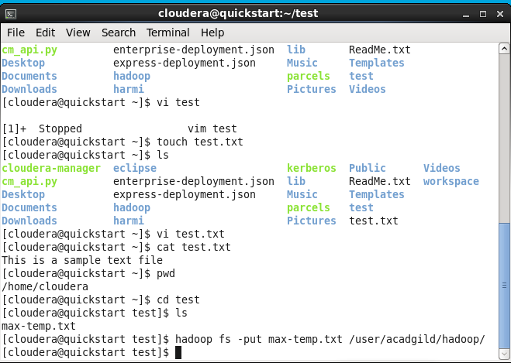

Task 4- Change the permission of the file /user/acadgild/hadoop/max-temp.txt,
only the owner and the group members have full control over the file.

